The two errors you'll face when trying to send a large file, without chunking
There is no explicit file size limit set by the FileReader API itself.
However, as you've just seen in the previous lecture, reading very large files (such as 5GB) at once with methods like fileReader.readAsArrayBuffer(file) often leads to errors or crashes because the entire file is loaded into memory, and available memory (browser and system) is the actual limiting factor.
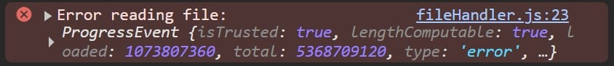
Second, even if your browser can handle loading the file, the WebRTC DataChannel has its own send queue. This is a buffer that temporarily holds data pending transmission over the network. This send queue has size limits (typically around tens of kilobytes), and if you try to send a very large message all at once, it will overflow, causing send queue errors. This is why you saw this error in the lecture:
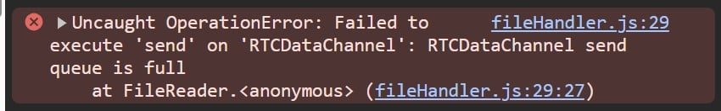
I'll expand on this later in the course, but for now understand that the send queue works like a flow control buffer that ensures data is sent at a rate the network and receiver can handle; overflowing this queue means the WebRTC DataChannel cannot process more data until some has been sent, leading to errors or stalls.
Don't stress, we'll fix these issues together, by implementing chunking.
Onwards and upwards 💪

